POSTMAN EVIDENCE - CHECKOUT FLOW
Waktu Eksekusi: 2026-07-23 17:34:24
--------------------------------------------------
[1] REQUEST: Inquiry Checkout Page
URL: https://tst.yokke.co.id:7778/gateway/IPGAPI/v1/inquiries
Status Code: 200
Request Body : {
"amount":1029,
"currency":"IDR",
"customer":{
"name":"john doe",
"email":"john.doe@test.com",
"phoneNumber":"08123456789",
"country":"Indonesia",
"postalCode":"12345",
"locality":"Jakarta",
"address":"Jl. Bahagia no. 1"
},
"order":{
"id":"LandingPage-17848028661759252",
"items":[{
"name":"Pertalite - Subsidi",
"quantity":1,
"amount":1029,
"url":"www.test.com",
"type":"BBM",
"id":"BBM-Subsidi"
}
],
"tokenOption":"off"
},
"referenceUrl":"https://demoshop.yokke.xyz"
}
Response Body:
{"id":"2df18b7e-d3ef-4cdf-9f13-9c2b3eba773e","createdTime":"2026-07-23T10:34:26.338Z","referenceId":"MILandingPage-17848028661759252","expirationTime":"2026-07-23T11:34:26.338Z","status":"unpaid","amount":1029,"currency":"IDR","paymentSources":["cybersource","mtiiso","bniapiva","cimb","gopay","indodana","kredivo","ovo","mandiriapiva","bridirectdebit","bricard","btniso","ocbciso","mtiqris"],"urls":{"selections":"https://tst.yokke.co.id:2443/checkout/6F3ZAR6vwmG5D2btpGWMdA","checkout":"https://tst.yokke.co.id:2443/checkout/6F3ZAR6vwmG5D2btpGWMdA"}}
--------------------------------------------------
[2] EXTRACTED GLOBAL VARIABLES:
Reference ID: LandingPage-17848028661759252
Landing Page: https://tst.yokke.co.id:2443/checkout/6F3ZAR6vwmG5D2btpGWMdA
Input Data Kartu
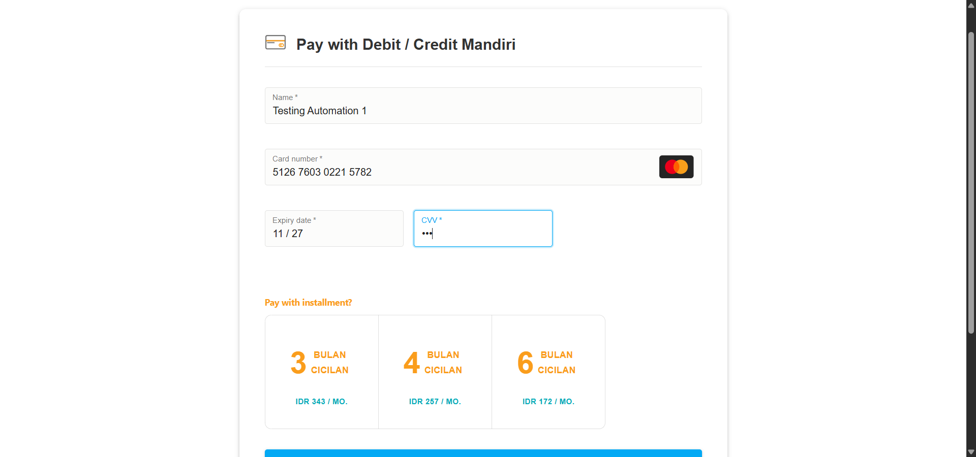
Hasil Payment
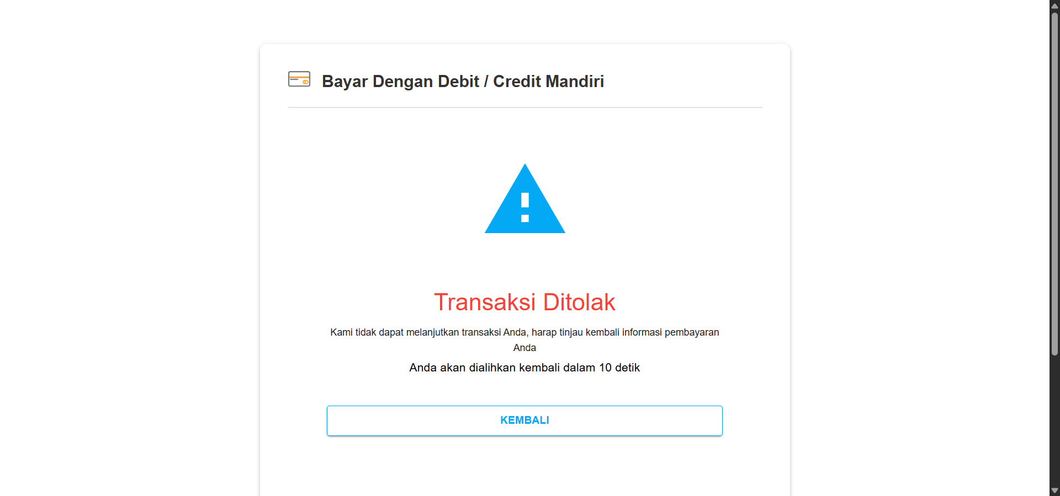
Admin
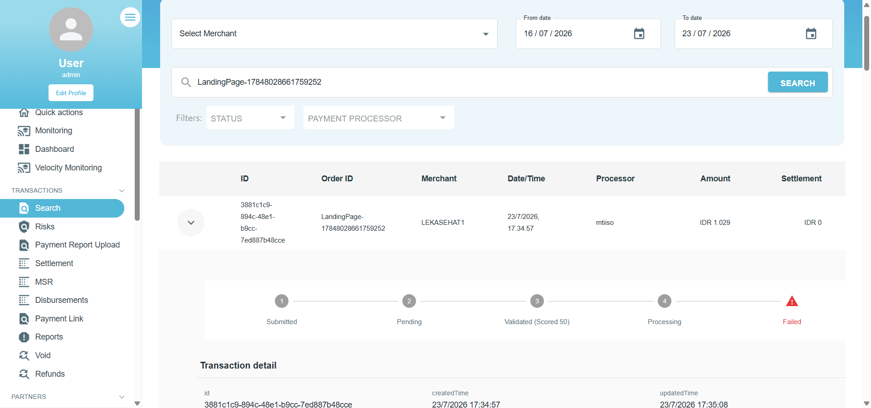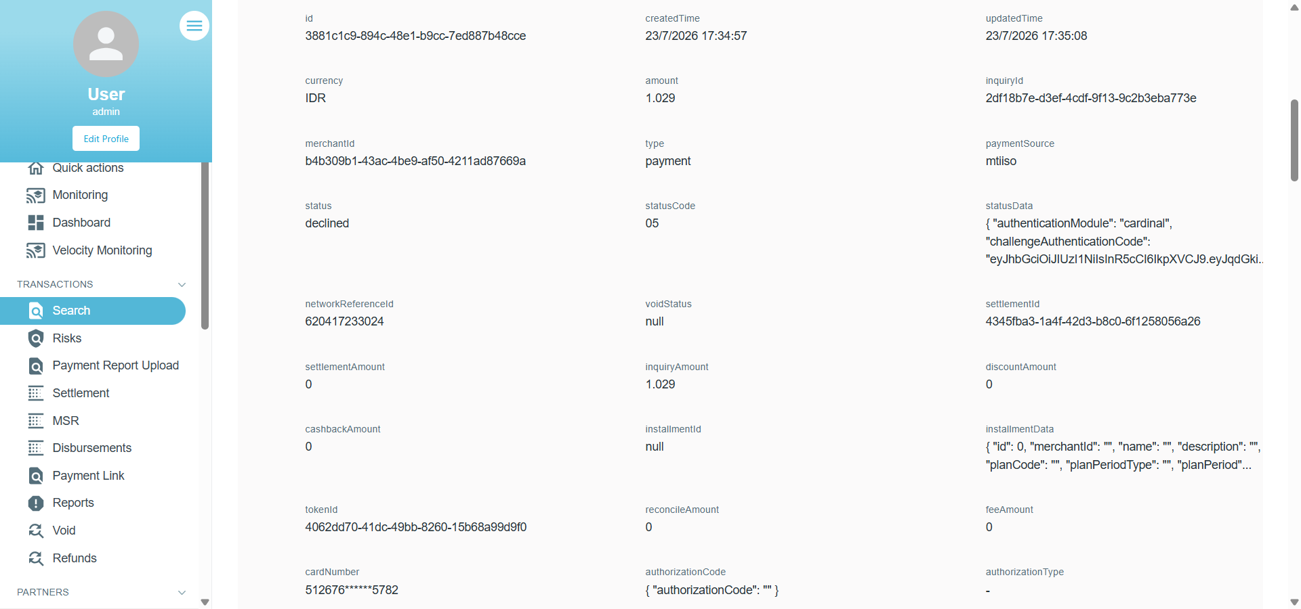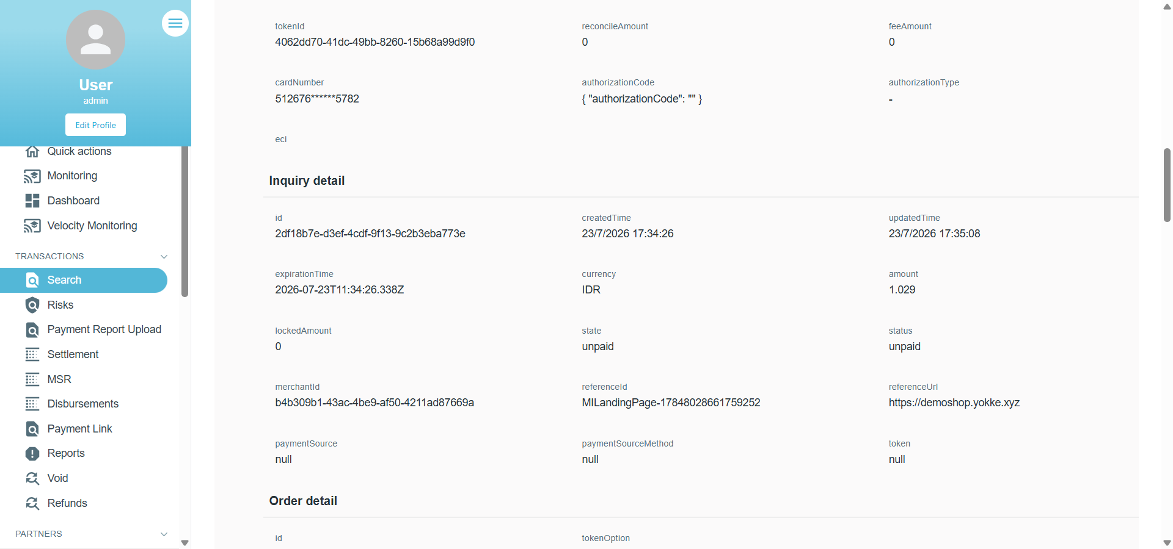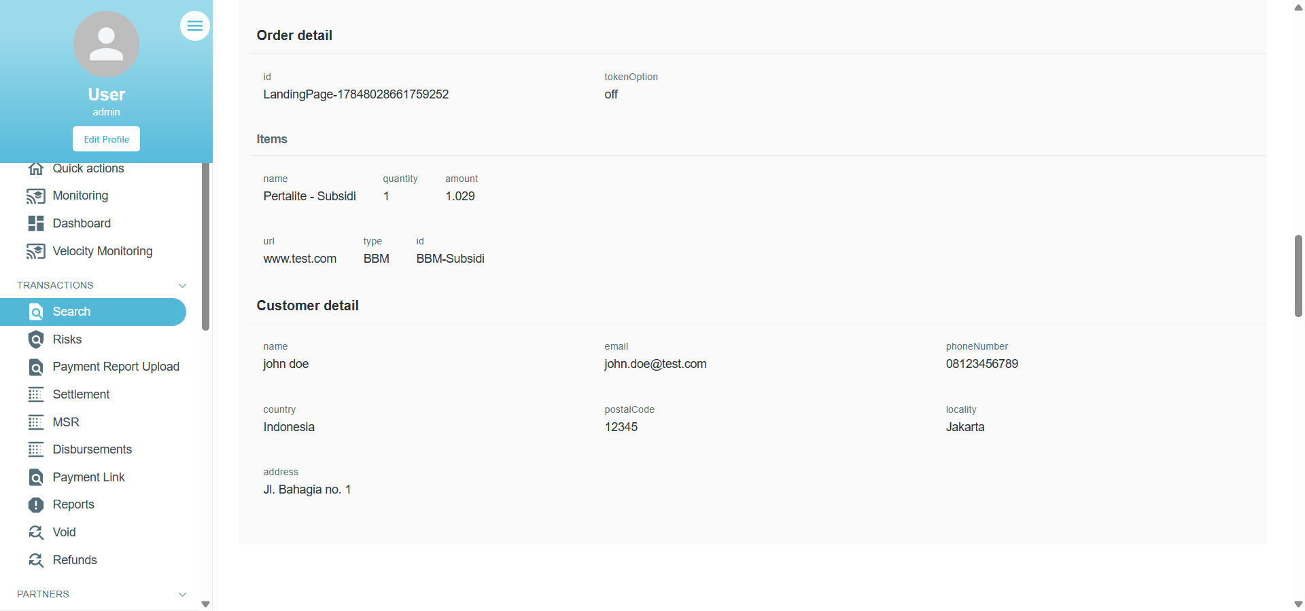
Database
Maas
FEP

